

**SEMESTER 1, 2024/2025**

**INFO 2302 WEB TECHNOLOGIES GROUP PROJECT PROPOSAL**

**SECTION 01**

**DEVELOPING A SHARIAH-COMPLIANT E-COMMERCE WEBSITE**

**PREPARED BY:**

|  |  |
| --- | --- |
| **NAME** | **MATRIC NO.** |
| MUHAMMAD IKHWAN BIN MAT SUHAIRI | 2317327 |
| MUHAMMAD ILHAM BIN MOHD HISHAM | 2316961 |
| MUHAMMAD IMRAN ZAHIDI BIN MOHD KHALIL | 2318165 |

**LECTURER**

**MDM. NURAZLIN BINTI ZAINAL AZMI**

**DUE**

**19/11/2024**

**TABLE OF CONTENT**

**INTRODUCTION TO SHARIAH COMPLIANCE 3**

**USER INTERFACE (UI) DESIGN PLAN 5**

**TARGET AUDIENCE 7**

**RESPONSIVE DESIGN 8**

**TEAM ROLES 9**

# 

# 

# 

# 

# 

# 

# 

# 

# 

# 

# INTRODUCTION TO SHARIAH COMPLIANCE

Shariah compliance is the practice of adhering to Islamic law, or Shariah, in business and financial transactions. A website is considered Shariah-compliant if it follows the principles of Islamic law, or Shariah, in its business practices and transactions. Some requirements for Shariah compliance include:

1. ***Ensure mutual benefit***

All transactions should be fair and ensure mutual benefit for both parties.

1. ***Avoid prohibited elements***

Transactions, products, and services must be free of prohibited elements like usury (riba), uncertainty, and gambling. For example, avoiding selling products or services that involve gambling, excessive speculation (maysir), or uncertain transactions (gharar) such as lottery tickets, betting-related products, or highly speculative financial products like Bitcoin. Moreover, avoid selling items that are prohibited in Islam, such as alcohol, pork, tobacco, gambling-related products, or adult material.

1. ***Clearly define products***

Sellers must clearly define their products, including their specifications, prices, delivery, and payment methods.

1. ***Ensure buyers and sellers have sufficient knowledge***

Both buyers and sellers must have enough knowledge about the values they are exchanging. This includes the existence, availability, quantity, quality, and attributes of the product or service.

1. ***Ensure both parties' consent***

Both the buyer and seller must have the legal capacity and authority to enter into the contract and must consent to it freely. This protects both parties’ rights and aligns with Islamic values that emphasize honest and willing participation in economic activities.

1. ***Ensure the object of the contract is lawful***

The object of the contract must be lawful, valuable, in existence, deliverable, and precisely determined. For instance, products that are harmful, or forbidden like alcohol and pork, or promote unethical behavior are not allowed.

1. **Respect for Customer Privacy**

Customer information is protected and safeguarded from being sold or misused to the public eye. A Shariah-compliant website only gathers necessary information for transaction-related processes.

1. **Fair & Honest Pricing**

Product prices are finalized without the intention of exploiting customers. Furthermore, discounts or promotions are offered sincerely without any misleading or deceptive terms.

# 

# 

# 

# 

# 

# 

# 

# 

# 

# 

# 

# 

# 

# 

# 

# USER INTERFACE (UI) DESIGN PLAN

1. **Simplicity In Design**

This concept will be applied especially for mobile users, where screen space is limited, so the users will not be overwhelmed with much information, thus not confusing them on how to navigate through the websites. Easy navigation means little work required by the users, therefore ensures a universal-friendly interface where users of different backgrounds and abilities can navigate the site comfortably. Without simplicity, users may experience a steep learning curve and are likely to disengage if the interface feels confusing or overwhelming.

1. **Consistency Across The UI**

Consistency in an e-commerce UI ensures that navigation buttons, fonts, and categories are in the same place across all pages, making the site easy to use and visually appealing. By keeping navigation predictable, users can quickly find what they need, saving time and reducing frustration. A uniform font style creates a clean look, while predictable category placement helps users know exactly where to go. This consistency gives the site a professional feel, making users feel more connected and comfortable as they shop.

1. **Accessibility & Adaptability**

Creating interfaces that function smoothly and look great on any device, whether it's a smartphone, tablet, laptop, or desktop. This involves designing elements that can resize and rearrange automatically based on screen size, resolution, and orientation (portrait or landscape). For example, images, text, and buttons should scale properly to remain clear and readable, while the layout structure should adjust to make efficient use of space. With responsive design techniques, a scalable and adaptable interface ensures that users have a consistently high-quality experience no matter how they access the site, making navigation and interaction comfortable and intuitive on any platform. This approach is essential for reaching a broad audience and supporting accessibility, enhancing the usability of the site across any type of device and user preferences.

Figure 1.1: Mobile UI - Home page Figure 1.2: Mobile UI - Product Page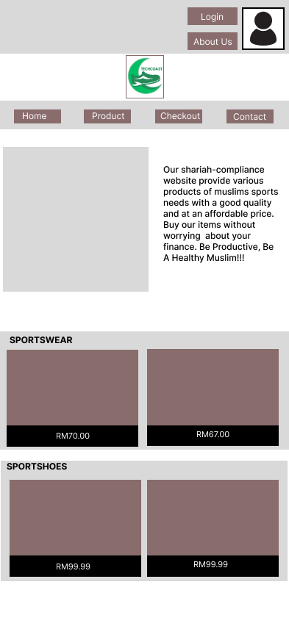 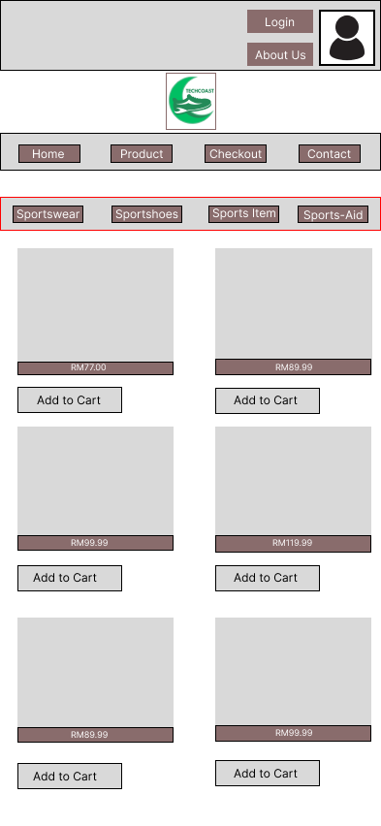

# 

# 

Figure 1.3: Mobile UI - Checkout Page Figure 1.4: Mobile UI - Contact Pag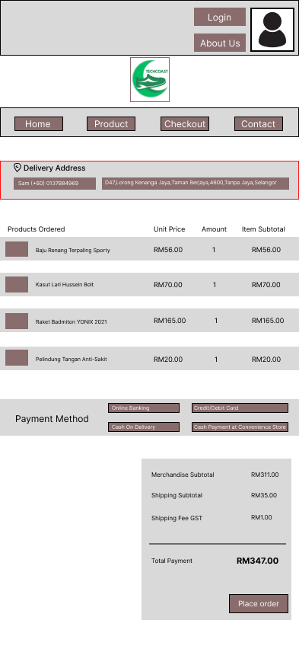 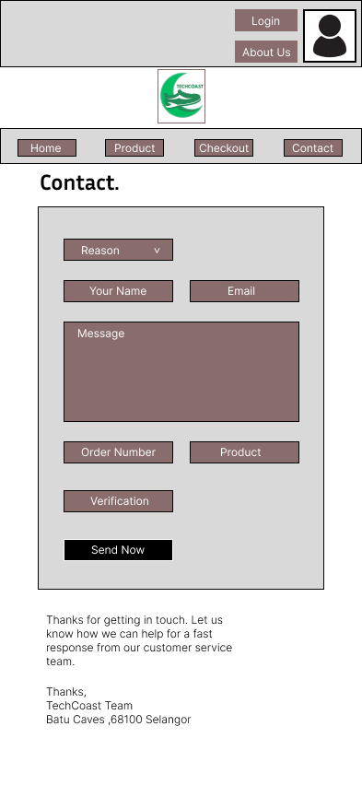

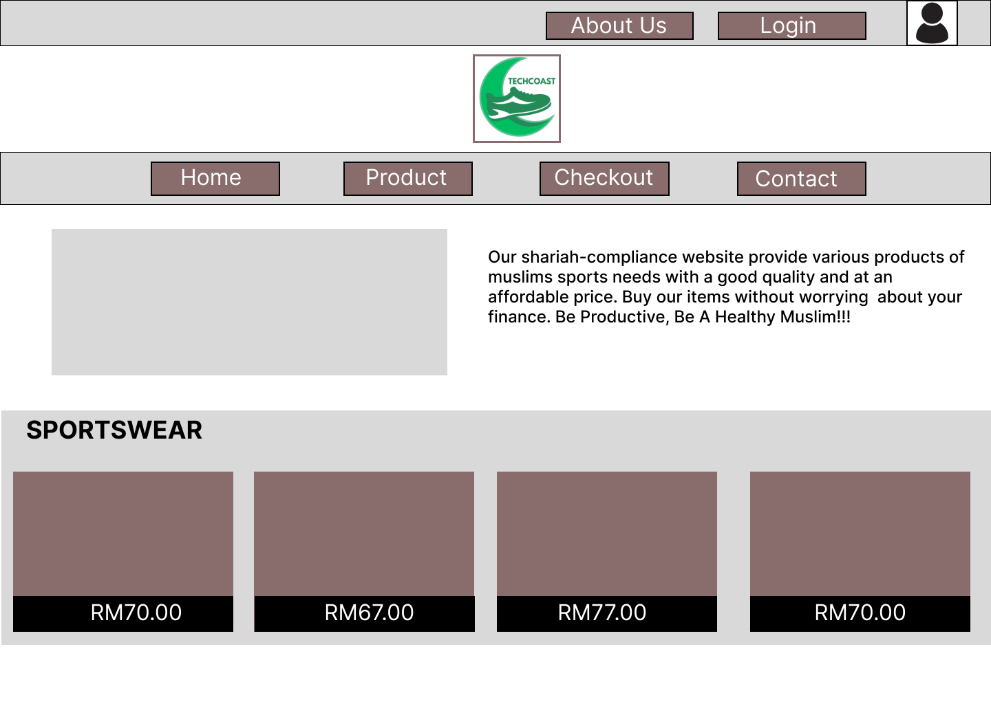

Figure 2.1: Desktop UI - Home page

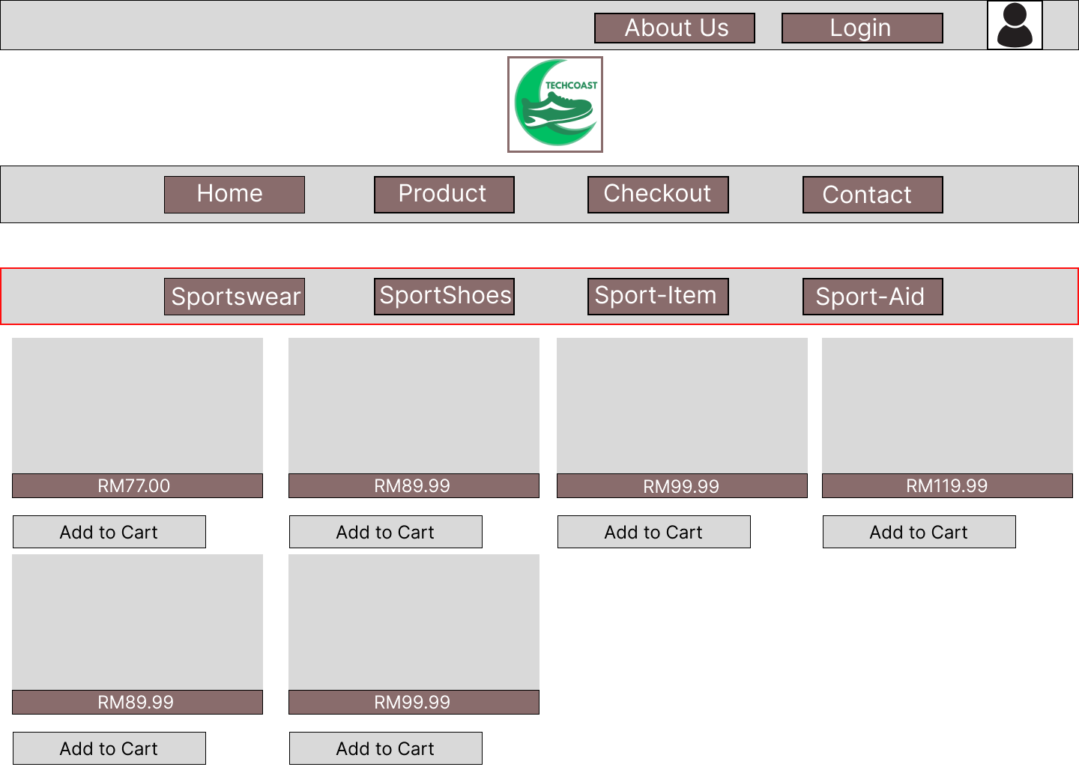

Figure 2.2: Desktop UI - Product Page

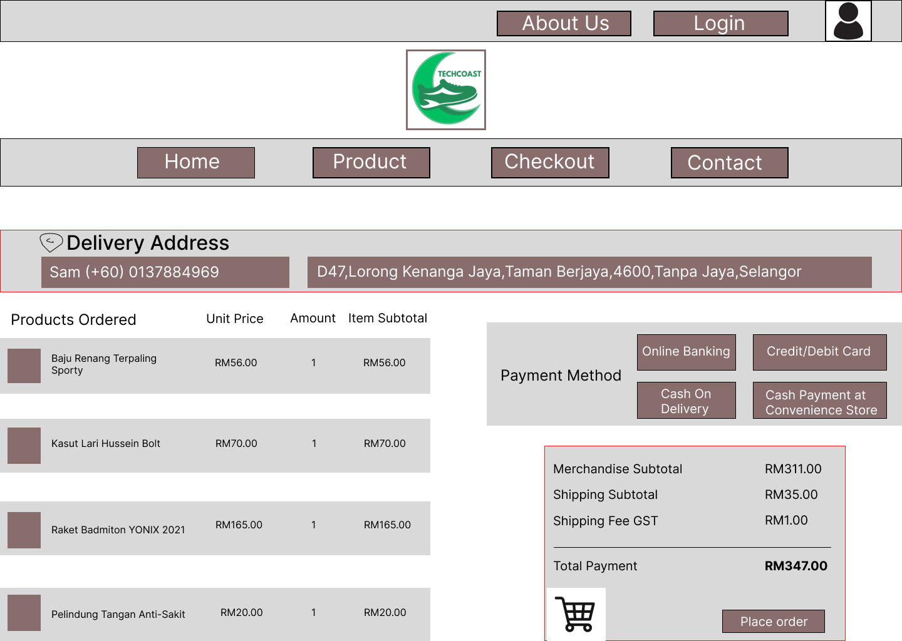

Figure 2.3: Desktop UI - Checkout Page

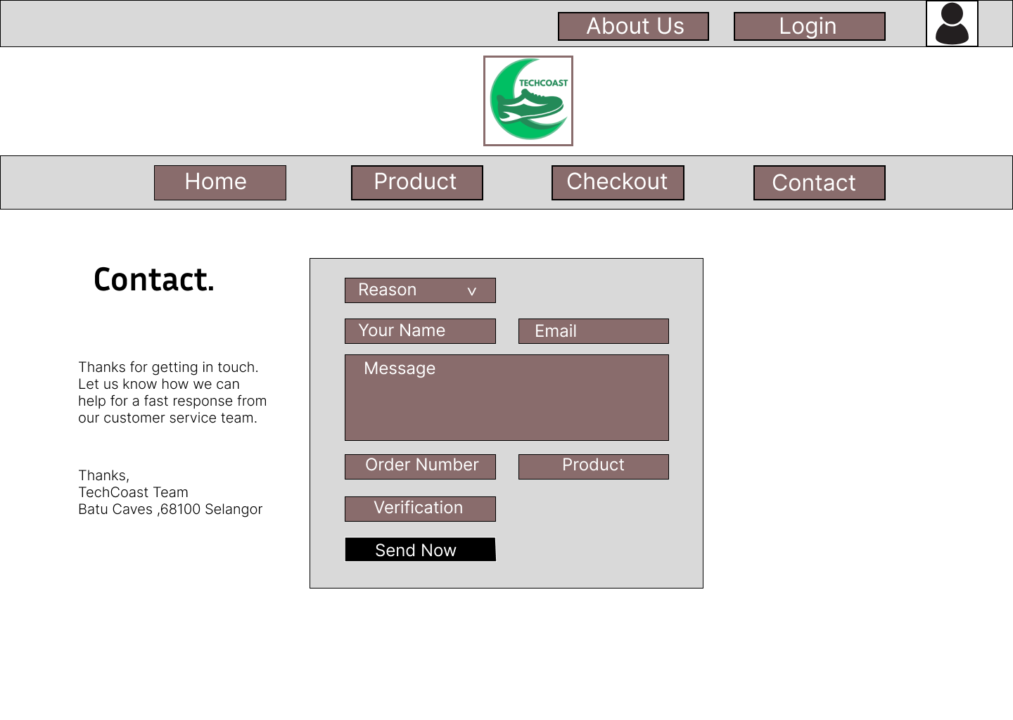

Figure 2.4: Desktop UI - Contact Page

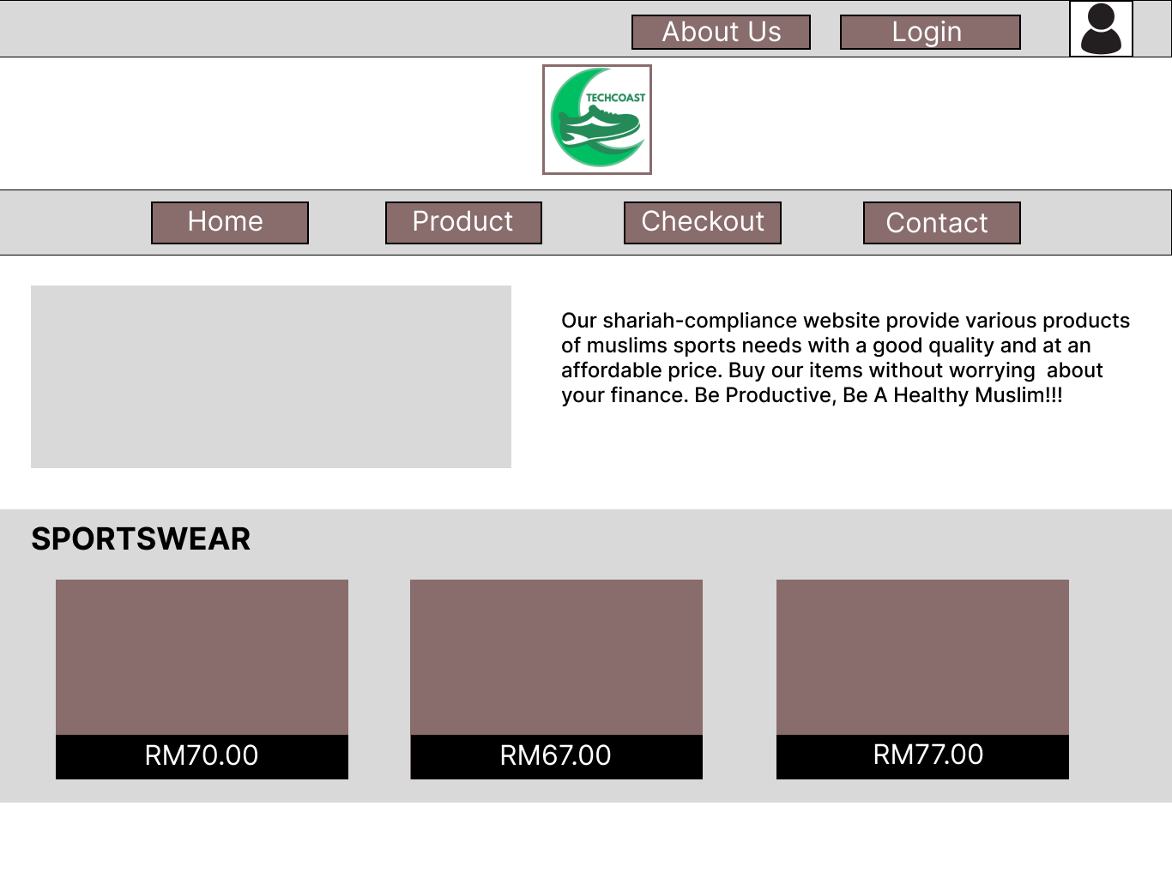

Figure 3.1: Tablet UI - Home Page

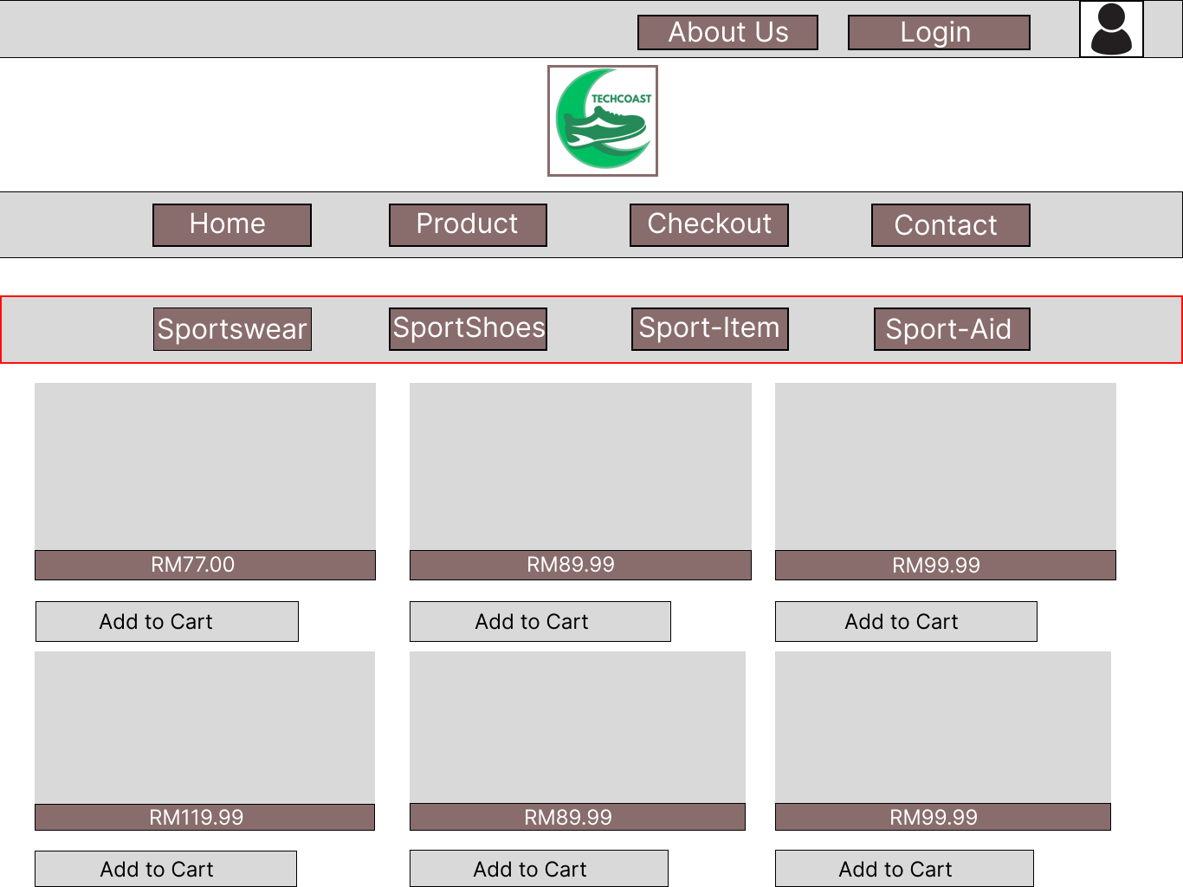

Figure 3.2: Tablet UI - Product Page

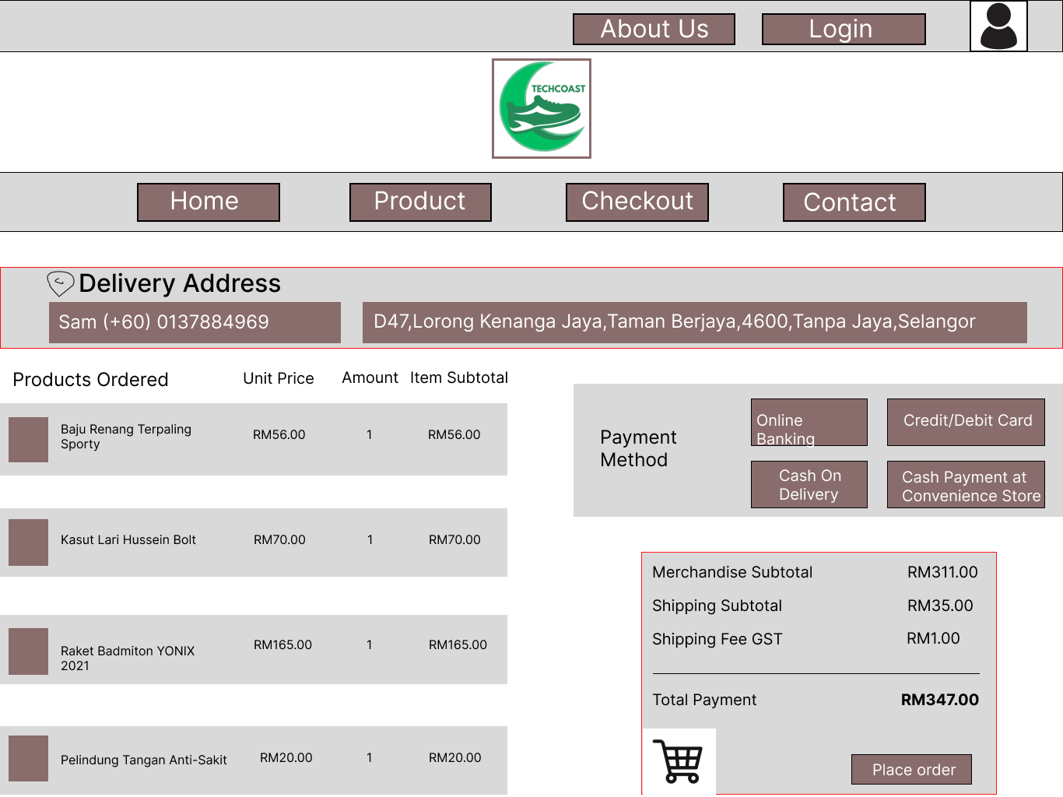

Figure 3.3: Tablet UI - Checkout Page

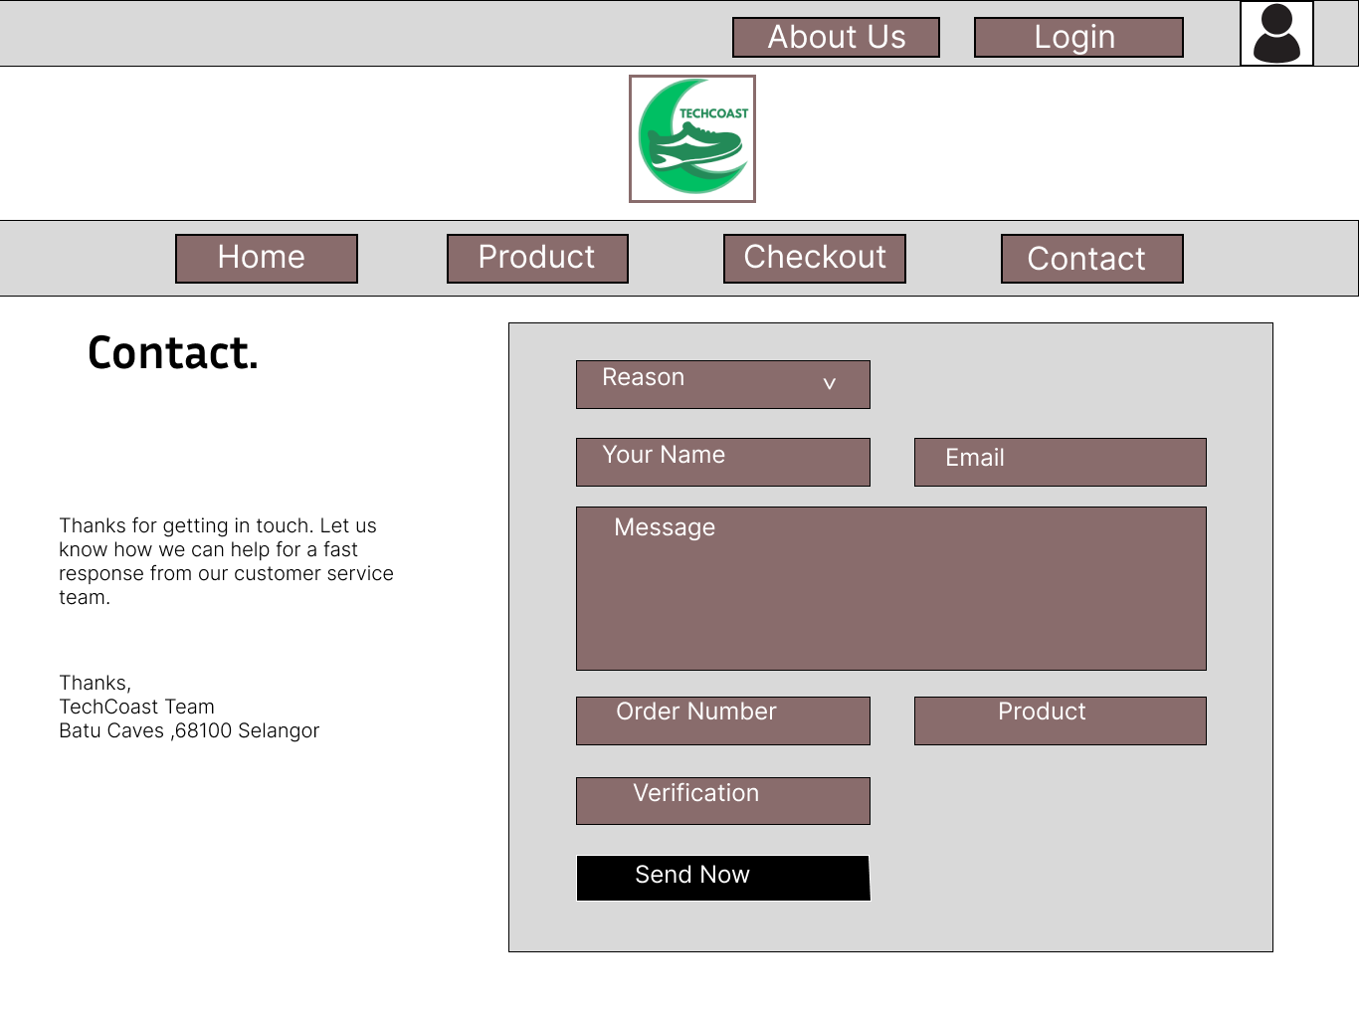

Figure 3.4: Tablet UI - Contact Page

# TARGET AUDIENCE

1. **Muslim Consumers**: Especially those who prioritize halal and Shariah-compliant products and services. They might be looking for products aligned with Islamic principles, such as modest athletic wear, halal-certified supplements, or ethical, socially responsible sporting goods.
2. **Health-Conscious Individuals**: People interested in maintaining a healthy lifestyle while also adhering to ethical or religious standards. This could include fitness enthusiasts, amateur athletes, or sports hobbyists who value transparency, honesty, and fairness in their transactions.
3. **Ethically-Minded Shoppers**: Consumers who prefer brands that uphold ethical standards—such as fair labor practices, environmentally sustainable materials, and transparency in sourcing—values that align closely with Islamic principles.
4. **Parents and Families**: Parents might be drawn to Shariah-compliant sports products for their children, including modest or gender-specific sports attire and products that meet ethical and halal requirements.
5. **Sports Organizations and Schools**: Muslim-focused sports academies, Islamic schools, and community centers could also be a segment, as they may seek Shariah-compliant sports equipment and attire for their members and students.
6. **General Global Muslim Community**: With the growing demand for halal and Shariah-compliant products worldwide, the platform could also appeal to international Muslim consumers interested in sports and fitness.

# RESPONSIVE DESIGN

The plan is to start designing the website for mobile devices first and then scale up to larger screens. This ensures the design works well on smaller screens before adding complexity to larger devices. It also allows us to focus on the core or necessary elements of the website first before moving on to the additional content.

**Desktop** - To make the site adaptable to desktop devices, the design should leverage the larger screen size and more advanced inputs to allow for complex interactions and multitasking. A clear and logical structure is essential to organize information and features effectively, helping users easily find and interact with content. Consistent, recognizable controls—such as buttons, checkboxes, radio buttons, sliders, and drop-down lists—will be incorporated to facilitate intuitive user input. Aesthetic options, like customizable themes, fonts, and color schemes, can enhance the experience by giving users a sense of personalization. Additionally, the 4-column layout implemented and hover effects can add layers of interactivity, allowing users to engage more deeply with the site’s content and navigate it efficiently on larger screens.

**Tablet** - The plan is to implement a 3-column layout with clear design elements and accessible, with larger buttons and text to improve readability and touch accuracy. Since tablet users often engage in task-based activities, a landscape layout is preferred, as it enables both hands to interact comfortably across a wider surface. Placing key targets and interactive elements near the edges and corners will improve reachability, allowing users to quickly access important functions without excessive hand movement.

**Mobile** - The “less is more” approach is applied, the main focus will be on essential content and removing unnecessary items like background images, decorative animations, or extra menus. To minimize space, a 2-column layout will be implemented. Using minimal, relevant content helps avoid clutter and reduces cognitive load, making it easier for users to focus on what’s important. Furthermore, a clear visual hierarchy must be established, meaning that menus and buttons are strategically placed for effortless access, guiding users intuitively through the interface. For example, Larger buttons, swipe gestures, and minimalistic layouts enhance usability, especially on smaller screens.

# TEAM ROLES

|  |  |
| --- | --- |
| **NAME** | **ROLES** |
| MUHAMMAD IKHWAN BIN MAT SUHAIRI | Introduction, UI design plan, Responsive Design |
| MUHAMMAD ILHAM BIN MOHD HISHAM | Target Audience, UI design plan |
| MUHAMMAD IMRAN ZAHIDI BIN MOHD KHALIL | Introduction, UI design plan |